Bitcoin Market Sentiment & Trader Behavior Analysis

Introduction
Cryptocurrency markets are heavily influenced by investor psychology and emotional market conditions. The Fear & Greed Index is widely used to measure overall market sentiment, ranging from Extreme Fear to Extreme Greed. Understanding how traders behave under different market sentiments can provide valuable insights into profitability, risk-taking behavior, and trading efficiency.
This project analyzes the relationship between Bitcoin market sentiment and trader performance using two datasets:
- Bitcoin Market Sentiment Dataset (Fear & Greed Index)
- Historical Trader Data from Hyperliquid
The objective of this analysis is to identify how market sentiment impacts:
- Trading activity
- Profitability
- Win rate
- Risk exposure
- Long and short positioning
- Asset-level performance
The project combines financial analytics, behavioral finance concepts, and data visualization techniques using Python.

Dataset Description

1. Bitcoin Market Sentiment Dataset

Features
- Timestamp
- Fear & Greed Value
- Sentiment Classification
- Date

Sentiment Categories
- Extreme Fear
- Fear
- Neutral
- Greed
- Extreme Greed
This dataset represents the emotional state of the crypto market on a daily basis.

2. Historical Trader Dataset

Features
- Account
- Coin
- Execution Price
- Size Tokens
- Size USD
- Side
- Direction
- Closed PnL
- Fee
- Timestamp
- Order Information
This dataset contains over 200,000 crypto trades executed by traders on Hyperliquid.

Methodology

Data Preprocessing
The following preprocessing steps were performed:

1. Data Cleaning
- Removed inconsistencies
- Converted timestamps into datetime format
- Standardized dates across datasets

2. Feature Engineering
Created additional features including:
- Trade Date
- Win/Loss Indicator
- Aggregated profitability metrics

3. Dataset Merging
The trader dataset was merged with the Fear & Greed dataset using date information.

4. Exploratory Data Analysis
Several statistical and visualization techniques were used to identify behavioral patterns.

Tools & Technologies Used

Programming Language
- Python

Libraries
- Pandas
- NumPy
- Matplotlib
- Seaborn

Exploratory Data Analysis

1. Trade Count by Market Sentiment

Observation
Fear sentiment dominated overall trading activity.

Key Findings
- Fear periods generated the highest number of trades.
- Greed periods showed moderate activity.
- Neutral and Extreme Greed had significantly lower participation.

Interpretation
This indicates that uncertain and volatile markets encourage traders to participate more actively. Fear-driven markets may create more short-term opportunities, panic reactions, and speculative behavior.

2. Average Closed PnL by Sentiment

Observation
Greed sentiment produced the highest average profit per trade.

Key Findings
- Greed showed the highest average profitability.
- Fear produced moderate average profits.
- Extreme Greed and Neutral showed lower profitability.

Interpretation
Bullish market conditions appear to create more efficient trading opportunities. However, profitability declined during Extreme Greed, suggesting that excessive optimism may reduce decision quality and increase overtrading behavior.

3. Total Closed PnL by Sentiment

Observation
Fear sentiment generated the highest cumulative profits.

Key Findings
- Fear markets produced the largest total profits.
- Greed ranked second.
- Extreme Greed and Neutral contributed relatively little.

Interpretation
Although Greed produced higher profits per trade, Fear markets generated substantially more trading activity. As a result, the total cumulative profitability was highest during Fear periods.
This suggests that volatile environments create larger overall trading opportunities.

4. PnL Distribution Analysis

Observation
Fear markets displayed the widest PnL distribution.

Key Findings
- Fear produced both the largest profits and the largest losses.
- Greed also showed high profitability but included large negative outliers.
- Extreme Greed had lower volatility.

Interpretation
Fear markets are highly volatile and reward skilled traders while exposing weaker traders to significant losses. The presence of extreme outliers indicates elevated market uncertainty and aggressive position-taking.

5. Win Rate Analysis

Observation
Extreme Greed achieved the highest win rate.

Key Findings
- Extreme Greed had the highest percentage of profitable trades.
- Greed showed strong win rates.
- Fear had lower win rates despite higher total profits.
- Neutral sentiment produced the weakest results.

Interpretation
Fear markets generated fewer successful trades but significantly larger profits, while Extreme Greed produced more frequent wins with smaller returns.
This demonstrates that win rate alone does not determine overall profitability.

6. Long vs Short Position Analysis

Observation
Fear markets generated the highest long and short activity.

Key Findings
- Open Long and Close Long activity peaked during Fear.
- Short activity also increased significantly during Fear.
- Greed markets showed more balanced positioning.
- Extreme Greed displayed declining participation.

Interpretation
Fear-driven environments create elevated uncertainty, causing traders to rapidly adjust positions. Interestingly, long positions remained dominant even during Fear periods, suggesting that many traders treated market declines as buying opportunities.

7. Top Trader Analysis

Observation
Trader profitability was highly concentrated.

Key Findings
- A small group of traders generated disproportionately large profits.
- The top trader significantly outperformed the rest.
- Profitability distribution was highly uneven.

Interpretation
Crypto market profitability appears heavily dependent on trading skill, timing, and risk management. Volatile markets amplify differences between skilled and unskilled participants.

8. Coin-Level Profitability Analysis

Observation
Several alternative cryptocurrencies outperformed Bitcoin in total profitability.

Key Findings
- @107 generated the highest cumulative profit.
- HYPE, SOL, and ETH also produced strong returns.
- BTC was not the top-performing asset.

Interpretation
Traders may benefit more from volatility-driven opportunities in alternative assets than in traditional large-cap cryptocurrencies such as Bitcoin.

9. Correlation Analysis

Observation
Most trading variables showed weak direct correlations with profitability.

Key Findings
- Trade size strongly correlated with transaction fees.
- Closed PnL had weak correlations with trade size and execution price.
- Sentiment value showed minimal linear correlation with profitability.

Interpretation
Trader profitability depends more on strategic execution, timing, and behavioral responses than on position size alone.
The weak direct relationship between sentiment score and profitability suggests that market sentiment influences trader behavior indirectly through psychological and behavioral mechanisms.

Overall Findings
The analysis revealed several important behavioral-finance insights:

Fear Markets
- Highest trading activity
- Highest total profitability
- Highest volatility
- Largest profit and loss extremes

Greed Markets
- Highest average profit per trade
- More efficient trading conditions
- Strong profitability consistency

Extreme Greed Markets
- Highest win rate
- Lower total profitability
- Possible overconfidence and trend exhaustion

Trader Behavior
- Profitability concentrated among elite traders
- High volatility amplifies performance differences
- Strategic execution matters more than trade size alone

Asset Performance
- Alternative cryptocurrencies outperformed Bitcoin in profitability
- Volatility-driven assets generated stronger trading opportunities

Conclusion
This project demonstrates that market sentiment plays a significant role in shaping trader behavior and profitability in cryptocurrency markets.
Fear-driven markets produced the highest trading activity and cumulative profits, indicating that uncertainty and volatility create substantial opportunities for traders. Greed markets generated the highest average profitability per trade, while Extreme Greed revealed evidence of declining trading efficiency and possible overconfidence.
The analysis also showed that successful trading performance depends heavily on strategic execution, risk management, and behavioral adaptation rather than simple factors such as trade size or execution price.
Overall, the findings highlight the importance of behavioral finance in cryptocurrency trading and demonstrate how sentiment analysis can provide valuable insights for understanding market dynamics and trader performance.

trategy Idea 1 — Fear Market Volatility Strategy

Rule of Thumb
During Fear market conditions, traders should reduce leverage and focus on high-probability setups because Fear markets generate the highest volatility and largest loss outliers.

Evidence From Analysis
- Fear had:
  - highest trading activity
  - highest total profitability
  - highest volatility
  - largest losses and gains

Recommended Strategy
- Use tighter stop losses
- Reduce leverage exposure
- Trade selectively during high volatility
- Focus on experienced/high-performing trader segments

Expected Benefit
This strategy reduces catastrophic losses while still capturing volatility-driven opportunities.

Strategy Idea 2 — Greed Market Efficiency Strategy

Rule of Thumb
During Greed market conditions, traders should increase trade frequency moderately and prioritize trend-following strategies because Greed periods produced the highest average profit per trade.

Evidence From Analysis
- Greed had:
  - highest average profitability
  - strong win rates
  - more stable trading behavior

Recommended Strategy
- Increase participation in trending markets
- Use momentum-based strategies
- Maintain moderate leverage
- Avoid excessive exposure during Extreme Greed

Expected Benefit
This improves profit efficiency while avoiding overconfidence-driven losses.

Optional Bonus Ideas
You can mention these in “Future Work” even if not implemented fully.

Bonus 1 — Predictive Model
You can write:
A future extension of this project could involve training a machine learning model to predict trader profitability buckets using sentiment score, trade size, leverage behavior, and directional positioning features.
Possible models:
- Random Forest
- XGBoost
- Logistic Regression
Prediction targets:
- profitable trade / non-profitable trade
- volatility class
- high-risk trader behavior

Bonus 2 — Trader Clustering
You can write:
Traders can be clustered into behavioral archetypes such as high-risk aggressive traders, conservative traders, and momentum-driven traders using unsupervised learning techniques like K-Means clustering.
Possible clusters:
- aggressive scalpers
- volatility traders
- consistent low-risk traders
- high-frequency traders

Bonus 3 — Streamlit Dashboard
You can mention:
A lightweight Streamlit dashboard could be developed to allow interactive exploration of market sentiment, profitability metrics, trader behavior, and asset-level performance.

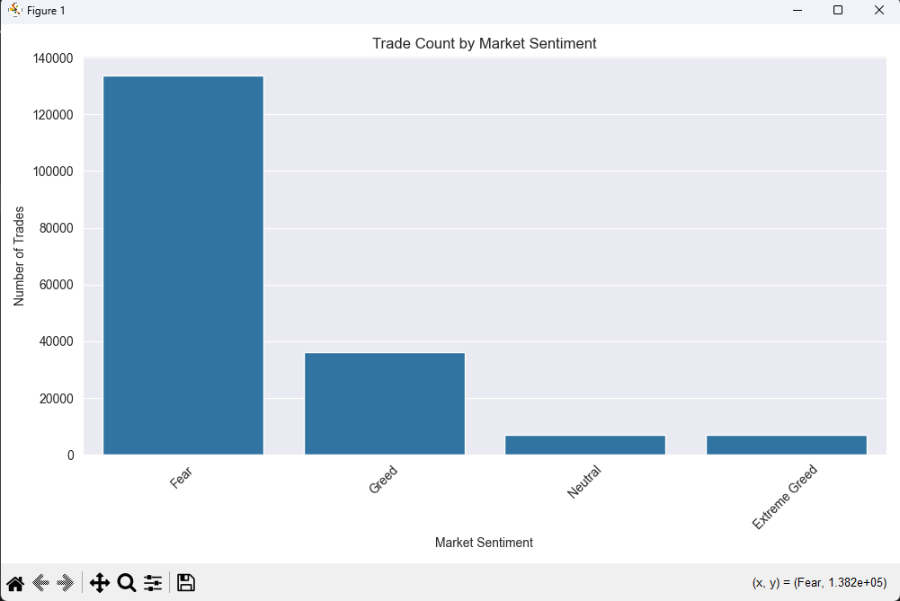
Traders were significantly more active during Fear periods compared to Greed or Neutral sentiment. This suggests that volatile or uncertain market conditions may encourage more trading activity, possibly due to panic selling, hedging, or increased speculative opportunities.
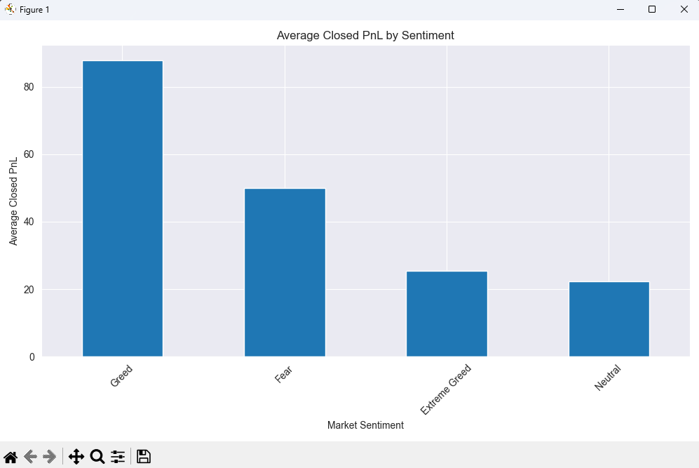
Traders earned the highest average profit during Greed sentiment.
Approximate values:
- Greed → ~88 average PnL
- Fear → ~50 average PnL
- Extreme Greed → ~25 average PnL
- Neutral → ~22 average PnL
Trader profitability was highest during Greed market sentiment, suggesting that bullish market conditions provide better profit opportunities for traders. Fear markets still generated moderate profits, while Neutral and Extreme Greed periods showed comparatively lower profitability.

Greed > Extreme Greed
It suggests:
- Moderate optimism helps traders
- Excessive optimism hurts performance
- Overconfidence during Extreme Greed may lead to poor decisions
Although traders performed well during Greed phases, profitability declined during Extreme Greed, indicating that excessive market optimism may encourage overtrading, increased risk-taking, or poor decision-making.

Another Important Observation
Earlier chart:
- Fear had the MOST trades
Current chart:
- Greed had the HIGHEST profits
This creates a very valuable contrast:
Market Sentiment | Behavior
Fear | Highest activity
Greed | Highest profitability
Interpretation:
Traders appear more active during Fear periods but achieve better profitability during Greed periods.
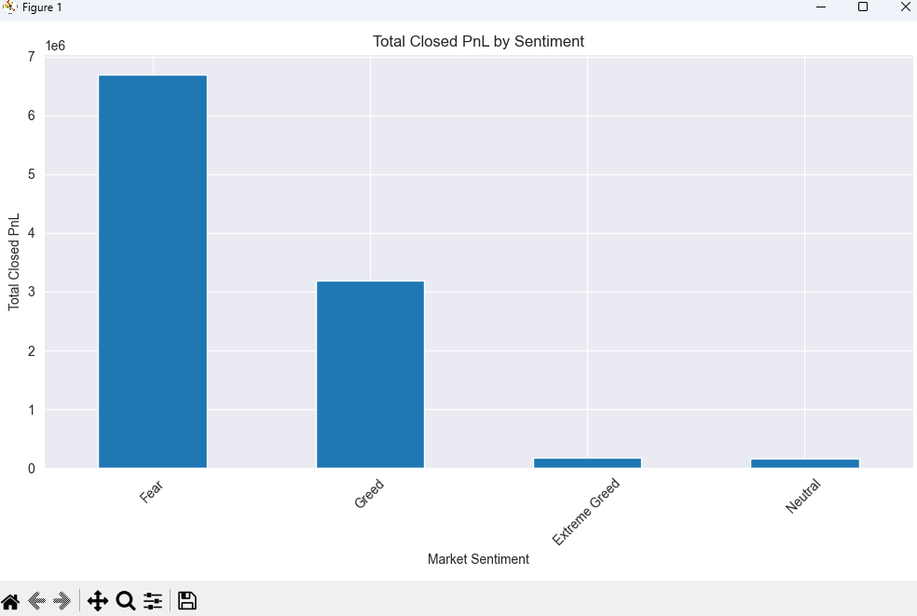

Total trader profits were highest during Fear markets.
Approximate totals:
- Fear → ~6.7 million
- Greed → ~3.1 million
- Extreme Greed → very low
- Neutral → very low
Although the average profitability per trade was highest during Greed periods, the highest total profits were generated during Fear sentiment due to substantially higher trading activity. This indicates that market uncertainty increases participation and creates more aggregate trading opportunities.
Extreme Greed contributes very little to total profits.
Possible reasons:
- overconfidence
- late entries
- market exhaustion
- irrational buying behavior
Extreme Greed periods generated comparatively low profitability, suggesting that excessive optimism may reduce trading efficiency and increase irrational market behavior.
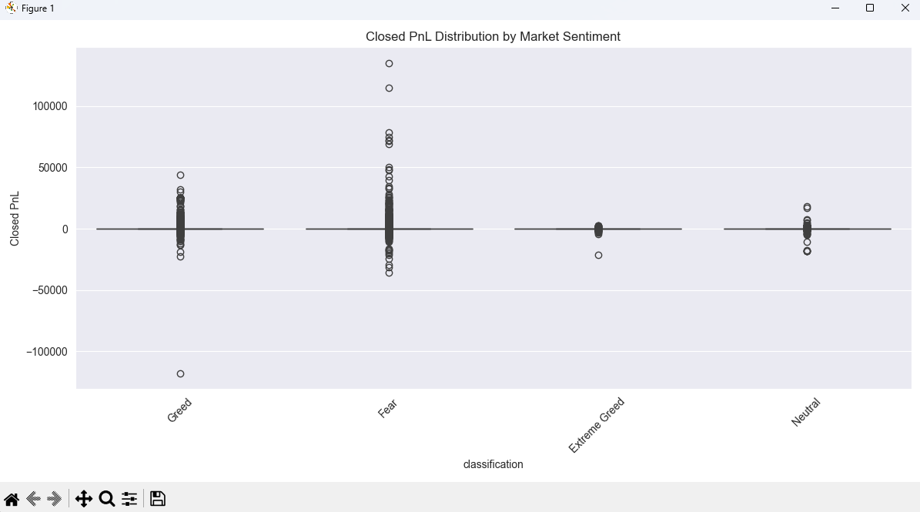
The PnL distribution analysis revealed that Fear markets exhibit the highest volatility, producing both the largest profits and the largest losses. This suggests that uncertain market conditions create substantial trading opportunities but also expose traders to elevated financial risk.\n\n> Greed periods demonstrated relatively stable profitability with fewer extreme losses, while Extreme Greed showed declining performance efficiency, likely due to overconfidence and late market participation.
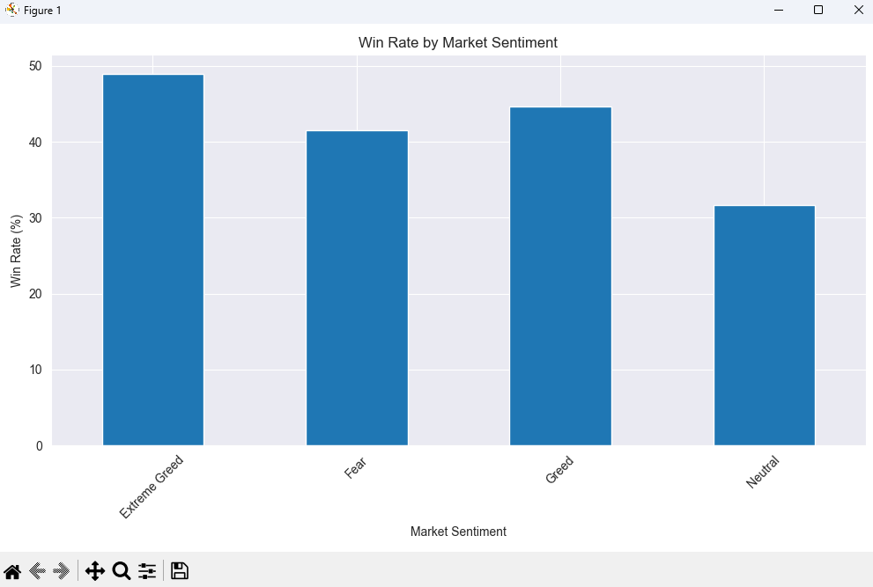
Win-rate analysis revealed that Extreme Greed markets produced the highest percentage of profitable trades. However, earlier profitability analysis showed that these trades generated relatively low overall returns. In contrast, Fear markets had lower win rates but substantially higher cumulative profits, indicating that volatile market conditions may produce fewer successful trades but significantly larger gains.
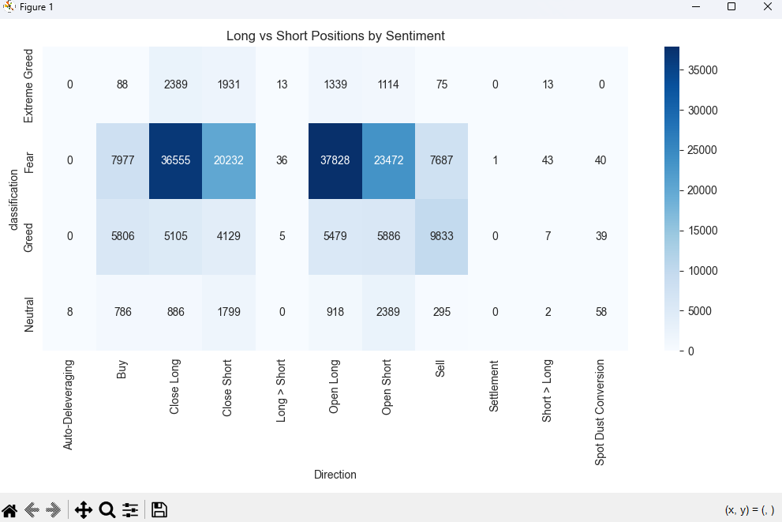
Directional trading analysis revealed that Fear markets generated the highest levels of both long and short activity, indicating elevated uncertainty and rapid position adjustments. Interestingly, long positions remained dominant even during Fear sentiment, suggesting that many traders viewed fearful markets as potential buying opportunities.\n\n> In contrast, Extreme Greed periods showed declining participation and reduced directional activity, indicating lower market engagement and possible trend exhaustion.
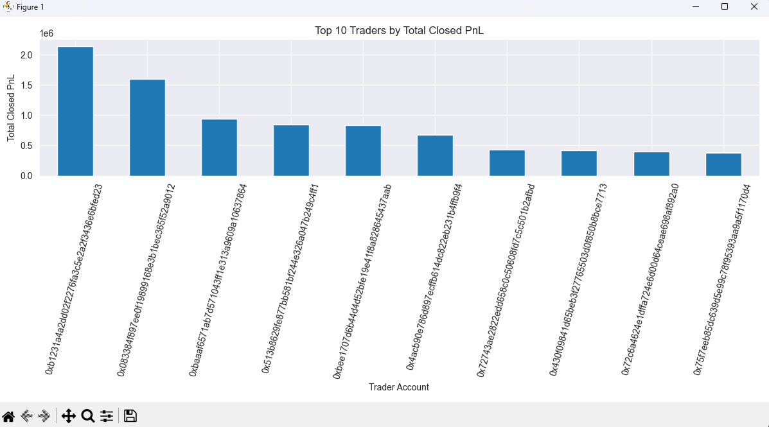
The significant profitability gap between top-performing traders and average participants suggests that trading outcomes are strongly influenced by strategy quality, execution timing, and risk management efficiency.
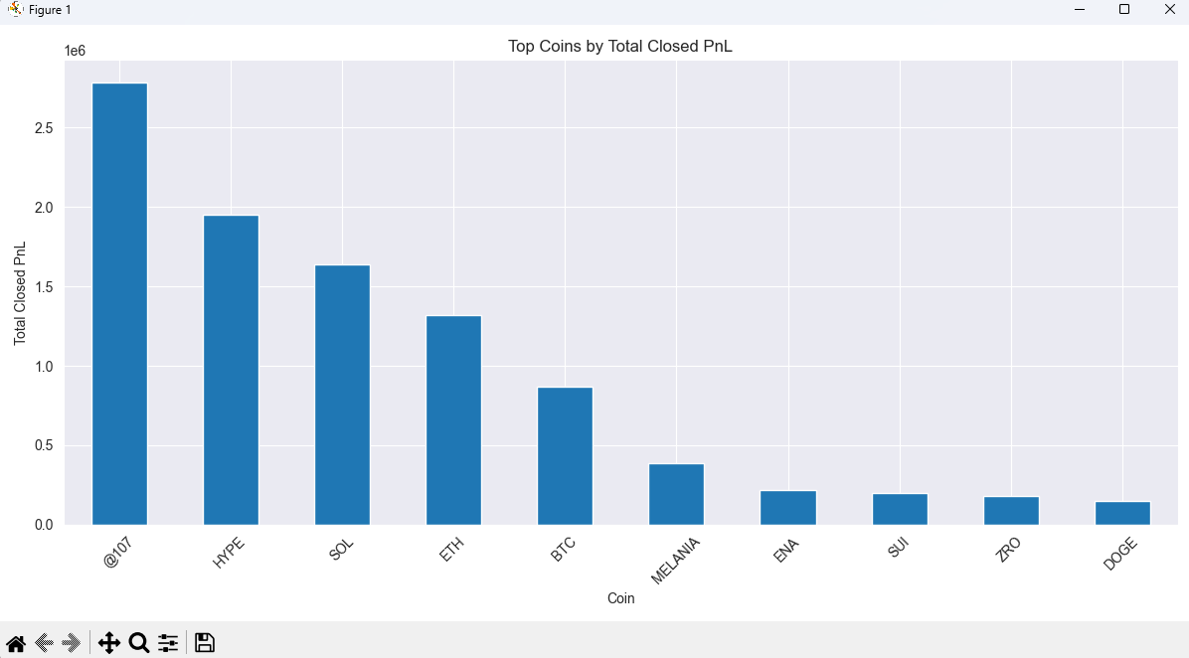
Coin-level profitability analysis revealed that trading profits were concentrated among a subset of highly volatile assets. Interestingly, several alternative cryptocurrencies outperformed Bitcoin in total trader profitability, indicating that traders may benefit more from volatility-driven opportunities in altcoin markets.
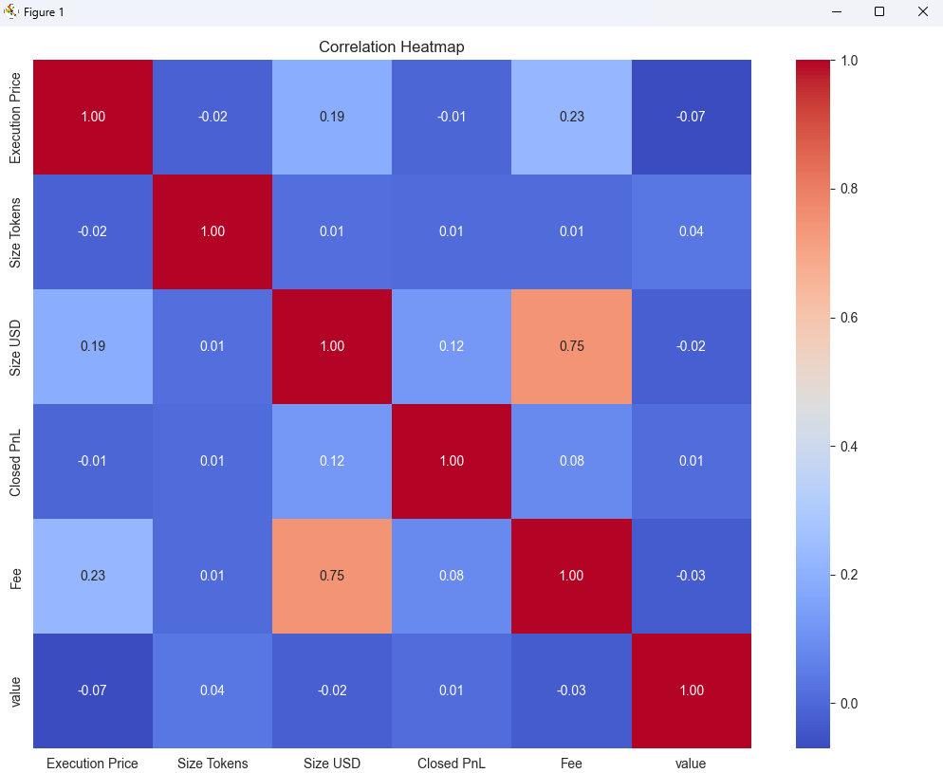
Correlation analysis revealed that trader profitability had relatively weak direct relationships with trade size, execution price, and transaction fees. This suggests that successful trading performance is influenced more by strategic decision-making and market conditions than by position size alone.\n\n> Additionally, market sentiment showed limited linear correlation with profitability, indicating that sentiment likely affects trader behavior through complex psychological and behavioral mechanisms rather than direct numerical relationships.

References
- Bitcoin Fear & Greed Index
- Hyperliquid Historical Trading Data
- Python Data Science Libraries Documentation
- Behavioral Finance Research Concepts

